Policy: | Health and Safety Policy  (incorporating First Aid Policy and lone working guidance)
Date or review: | December 2020
Date of next review: | December 2022
Lead professional: | Chief Operating Officer
Status: | Statutory
Key personnel in this academy – is listed in Appendix 3.

- Purpose of policy and guiding principles

  - Trinity Multi Academy Trust’s (Trinity MAT) Board of Directors have overall responsibility for ensuring that each academy within the trust adheres to the Health and Safety Policy and arrangements of the trust. The Local Governing Body (LGB) has primary responsibility for monitoring health and safety practice and procedures at each site, ensuring that appropriate policies and procedures are in place and are followed.

  - The trust recognises and accepts that all employees, students and visitors to each academy, or trust site, are entitled to a safe and healthy environment.

  - All appropriate steps will be taken to meet statutory requirements, recognised codes of practice and guidance notes, in establishing a robust safe and healthy environment and culture.

  - The overall high quality of the environment will be evidence of a strong ethos of housekeeping, which will pass into each academy community. An awareness of the appearance of the building will be demonstrated by students and employees on a daily basis.

  - All employees have a duty and responsibility to take reasonable care to avoid injury to themselves and others and to co-operate to ensure statutory duties and obligations are fulfilled. This Health and Safety Policy can only be successful with the full co-operation of everyone concerned.

  - The trust and individual academies will seek advice and support (when required) from appropriate organisations to ensure that Health and Safety is maintained to the highest standard.

  - This policy is underpinned by the Health and Safety at Work Act 1974 and all other relevant legislation. This policy should be read in conjunction with the trust Premises Management Policy and plans.

  - Department for Education (DfE) guidance notes on the statutory responsibilities for a trust or an individual academy should be followed.

  - This policy does not cover an individual academy’s requirement to deliver a Safety Education curriculum (PSHE or other). However, the Premises Manager may be able to offer advice or guidance as to where curriculum leaders can find appropriate resources.

- Statement of intent and objectives

  - Trinity MAT aims to ensure that so far as is reasonably practicable:
    - All employees, students, members of the public; including parents/carers, visitors and contractors’ employees; who enter trust premises, are not exposed to any Health and Safety hazards during the course of their business;
    - No work will be carried out by the trust employees or contractors that are liable to expose employees, students or members of the public to hazards to health, unless suitable and sufficient assessments of the risk are made and necessary measures to prevent or control the risk have been introduced;
    - All contractors are able to demonstrate that they have suitable risk assessments and arrangements for securing proper Health and Safety, including, where necessary, a written statement of policy.

  - The trust’s objectives are to:
    - Provide conditions and systems of work for all employees which prevent any danger to health. This requires risk assessments to be carried out as appropriate to enable hazards and risks to be identified to enable the standards of safety to be adapted and enforced;
    - Ensure that all plant and equipment is maintained properly and that neither will be knowingly used when it presents any risks to the safety of the staff or the public;
    - Provide comprehensive information, instruction, training and supervision, so far as is reasonably practicable, to ensure the Health and Safety at work of all employees and pupils/students;
    - Ensure that the health, safety and welfare of all employees, students and members of the public are under continuous review by management at all levels in the organisation (both centrally and in each academy for the avoidance of doubt);
    - Ensure safe arrangements are made for the storage, handling and transport of articles and substances;
    - Ensure that each academy has, and maintains, up-to-date fire procedures and documentation and that all employees and students are familiar with them;
    - Develop safety awareness among all employees and students and promote individual responsibility for Health and Safety at all levels in the organisation (both centrally and in each academy for the avoidance of doubt);
    - To ensure that our standards are communicated to all employees, associated employees and contractors.

- Roles and responsibilities

  - The Board of Directors/Local Governing Board

In discharging their responsibilities, the Directors and Local Governing Board members will:

    - Make themselves familiar with the requirements of the appropriate legislation and codes of practice;
    - Create and monitor a management structure for Health and Safety;
    - Ensure that there is an effective and enforceable policy for the provision of health and safety throughout the academy, and that it is implemented;
    - Periodically assess the effectiveness of the policy and ensure that any necessary changes are made;
    - Identify and evaluate risks relating to possible accidents and incidents connected with academy-sponsored activities, including work experience.

  - In particular, the Directors and Local Governing Board members undertake to provide, as far as reasonably practicable:

    - A safe place for all users of the site to work, including safe means of entry and exit;
    - Plant, equipment and systems of work that are safe;
    - Safe arrangements for the handling, storage and movement of articles and substances;
    - Safe and healthy working conditions that take account of appropriate statutory requirements, code of practice and guidance;
    - Supervision, training and instruction so that all staff and students can perform their academy-related activities in a healthy and safe manner;
    - Provide safety and protective equipment and clothing, with associated guidance, instruction and supervision.

  - The Principal of each academy

    - Each Principal is responsible for the safety and security of their students, staff and premises;
    - Each Principal will take advice from the premises team in Health and Safety matters, including opening/closing the academy or restricting access to certain areas of the academy to ensure the safe operation of the building;
    - Each Principal will have a staffing structure which makes clear where the responsibilities for Premises Management lies, within their academy. Where required, the Principal will ensure that a training budget in relation to Health and Safety requirements is available and relevant staff have appropriate access to training.

  - The Premises Manager (Health and Safety Co-ordinator)

The Premises Manager has responsibility for the day-to-day development and implementation of safe working practices and conditions for all staff, students and visitors. They will take all reasonably practicable steps to ensure that the Health and Safety Policy is implemented. In particular they will:

    - Have overall responsibility for the day-to-day running of the academy in respect of health and safety matters (including reviewing safe systems of work on a regular basis);
    - Ensure health and safety is a normal feature of the academy and functions;
    - Ensure relevant leaders receive the necessary information, policies and procedures to enable them to fulfil their necessary obligations with respect to all health and safety matters;
    - Ensure all employees have access to a copy of the academy’s Health and Safety Policy and procedures and have received adequate safety training;
    - Update and review the safety procedures at the academy on a regular basis;
    - Ensure a safety audit or inspection of the academy is completed on an annual basis;
    - When relevant, consult with professional Safety Advisers for specialist advice and assistance;
    - The Premises Manager will have in place an update record of Health and Safety Testing/Inspection relevant to their academy. The template in Appendix 1 provides an example of planned and preventative measures to support compliance to Health and Safety requirements;

  - Responsibilities of all staff

All staff are expected to familiarise themselves with the Health and Safety aspects relative to their area of work and avoid conduct which would put themselves or anyone else at risk.

  - In addition to the general duties that all members of staff have, all managers and curriculum leaders will be responsible to the Premises Manager for the implementation and operation of the Health and Safety Policy within their relevant departments and areas of responsibility.

  - In particular, members of staff will:

  - Be familiar with the Health and Safety Policy and all safety requirements laid down by the Governing Body;
  - Ensure that staff, students, visitors and contractors are applying Health and Safety regulations, rules, routines and procedures effectively;
  - See that all plant, machinery and equipment are in good and safe working order and adequately guarded, and not make or allow improper use of such plant, machinery and equipment;
  - Use the correct equipment and tools for the job and any protective equipment or safety devices that may be supplied;
  - Ensure that toxic, hazardous and highly flammable substances are correctly used, stored and labelled;
  - Report any defects in the premises, plant, equipment and facilities that they observe to the Premises Manager;
  - Take an active interest in promoting Health and Safety and suggest ways of reducing hazards.

  - For leaders who work within higher risk areas (such as Science departments and practical subjects). Those leaders will:

- Ensure health and safety is a normal feature of that area/department’s operations and functions and co-operate in the implementation of risk assessment and regular safety checks;
- Report any deficiencies in work procedures, unsafe practices or hazardous situations within their area of responsibility to the Health and Safety Co-ordinator, or in an emergency situation direct a Senior Leader;
- Be familiar with all policies and procedures outlined in the academy Health and Safety Policy relevant to their responsibility. It is important that heads of department ensure they have access to all relevant guidance notes and code of practice from outside bodies e.g. DfE, HSE, CLEAPSS Documentation etc;
- Department/Curriculum Leaders must also devise and maintain a curriculum area Health and Safety Handbook and appropriate risk assessments;
- Department/Curriculum Leaders must inspect all areas for which they are responsible on a monthly basis for health and safety hazards;
- Any teaching staff member using corrosive or hazardous fluids must be aware of COSHH requirements.

- Health and Safety arrangements

  - Fire Safety

    - Appropriate fire evacuation procedures for ensuring that safety precautions are properly managed will be formulated and sent round to all staff;
    - The academy’s evacuation procedure will be circulated and available on each academy shared areas and/or VLE and the health and safety notice board situated in the staffroom;
    - All staff and students must be fully aware with the procedures for evacuation of the premises in case of a fire/bomb threat. Evacuation procedures will be tested a minimum of three times during an academic year. The evacuation and safety of visitors and contractors will be the responsibility of the person who they are visiting or working for. All evacuations of the building are recorded and documents held with the Premises Manager;
    - All staff are aware of the fire evacuation and a copy of this procedure is explained to all new staff during their induction process. Please refer to the Critical Incidents and Business Continuity Policy for the full procedure;
    - All firefighting equipment will be checked annually by an approved contractor and records maintained. The fire alarm will be tested weekly from different points and records maintained. All emergency lighting will be tested monthly and annually and records maintained.

  - Reporting Accidents

All accidents to staff, students and visitors must be reported, in writing, using the trust or an individuals’ academy’s accident report form. The completed form should be given to the Health and Safety Manager. Certain accidents must be reported to the Health and Safety Executive under the Reporting of Injuries, Diseases and Dangerous Occurrences Regulations 2013 (RIDDOR). The Premises Manager/First Aid Co-ordinator will ensure that the Health and Safety Executive is informed of reportable incidents.

  - First Aid and medical needs

First Aid can save lives and prevent minor injuries becoming major ones. Under health and safety legislation, employers have to ensure that there are adequate and appropriate equipment and facilities for providing first aid in the workplace.

    - The First Aid Co-ordinator should ensure that the number of certified first-aiders will not, at any time, be less than the number required by law. In addition, supplies of first aid material should be held at various locations throughout the academy. These supplies should be checked on a regular basis by the First Aid Co-ordinator/Medical Welfare Officer;
    - The academy has a designated team who hold a First Aid qualification. The list of staff is available via the First Aid Co-ordinator. This person has the day-to-day responsibility of ensuring there are enough trained staff and co-ordinating training arrangements;
    - The first aid team has responsibility for administering treatment for minor injuries which (after being assessed by them and at least another first aid trained professional) do not need hospital treatment. If a first aider has to administer treatment, the student’s parent must be informed of the injury and the treatment administered. Contact will be made by the academy’s Medical Welfare Officer or another member of the pastoral team;
    - If the Medical Welfare Officer believes hospital treatment is required they should either contact an ambulance or contact the parent/carer to take their child to the hospital. A senior leader should be informed if a student is taken to hospital;
    - All staff have the responsibility to contact a first aider in the event of a medical emergency;
    - There is a separate policy in place for students with medical needs; please refer to this for further information;
    - Medical equipment and medication should be stored as directed by manufacturers/health care professionals. Syringes and other medical equipment should be disposed of safely in the appropriate container.

- Equipment

  - Protective clothing/gloves/masks/helmets must be provided and used by technicians and site supervisory staff when required. Staff and students must be provided with and use protective glasses/eye shields in all workshops and laboratories. Visitors must be provided with protective clothing as appropriate.

  - The academy retains a list of plant and equipment that must be checked regularly by approved inspectors or an appropriately trained member of staff. Records of all checks are kept in the Premises Manager’s office. Examples of this type of plant and equipment are:
- Fume cupboards;
- All electrical appliances;
- All boiler and biomass equipment;
- Workshop equipment e.g. drills, lathes, band saws;
- Fixed gymnasium equipment.

  - When new equipment is purchased it is the responsibility of the department
leader, with the assistance of the Premises Manager as necessary, to ensure that it meets appropriate educational standards and that its installation and use conforms to Health and Safety requirements.

  - Equipment, materials and chemicals must be stored in the appropriate storage containers and areas. All containers must be labelled with the correct hazard sign and contents label. Managers should consider storage life when ordering new supplies. Reference must be made to COSHH and the Ionising Radiations Regulations; copies of all relevant COSHH and regulations must be kept in the Science department.

- Housekeeping

  - The Premises Manager will monitor the cleaning standards of the cleaners. The standard required is laid down in the cleaning specification. Special consideration will be given to hygiene areas.

  - The Premises Manager will monitor the efficiency of the waste collection service. Separate provision must be made for the collection and disposal of laboratory materials (chemicals, broken glass etc.), clinical waste and normal refuse.

- Visitors to the academy site

  - All visitors to the academy will sign in at the reception. Visitors will be collected from reception by the member of staff concerned or escorted to the appropriate area of the academy. The Child Protection and Safeguarding Policy and Safeguarding Procedures (Visitors and Volunteers) explains the procedures as regards to any visitors.

  - No contractor may undertake work on the academy site without permission from the Premises Manager other than in an emergency e.g. fire, flooding, or to make safe following theft/vandalism.

  - Contractors are responsible for the Health and Safety of their employees and for their safe working practices, which must not constitute a hazard to staff, students and visitors to the academy.

  - Hirers of the academy premises must use plant, equipment and substances correctly and use the appropriate safety equipment. They will be made aware of their obligations in relation to Health and Safety when making their booking.

- Security

  - All staff should be conscious of all aspects of the security of people and property. In particular, the emergency exit doors on the outer perimeter of the buildings should only be used in the event of emergencies and kept secure at all other times.

  - Maintaining security is aimed at reducing the opportunity for unauthorised persons to enter the buildings through non-designated access points. It is also necessary to be alert to the possible presence of unauthorised persons on site who may constitute a threat to staff, students and bona-fide visitors and contractors.

  - If a visitor or potential intruder in and around the site is uncooperative, or a member of staff feels threatened, or is threatened with violence or a violent attack takes place, immediate help from the Police should be sought.

- Critical incidents

  - As part of its commitment for the wellbeing of staff, students and visitors, the academy has set out a procedure which is to be adopted in the event of a critical incident occurring, either on the academy premises or on an activity away from the academy site. (Please refer to the academy Critical Incident Procedures and Plans)

- Coping with the sudden death of a student, employee or visitor

  - In the unlikely event that the academy has to deal with the sudden death of a student, employee or visitor, it is advised that initially any member of staff seeks guidance from a member of senior leadership. It may be advised that guidance is also sought from the Police, the LA, the DfE and any other applicable agencies regarding how to deal with this situation and how the communication of an incident like this should be handled.

- Lone working

  - The trust recognises that there may be a requirement for staff to ‘work alone’. These are staff who work by themselves without close or direct supervision.

  - The trust, as the employer, is responsible for the health, safety and welfare of all workers, including those that work alone. Generally, workers who work alone are scheduled to work outside usual academy hours; please see Appendix 2 for all details.

- Risk assessments

  - All members of staff in charge of a departmental area or curriculum area are responsible for ensuring that hazards are identified and appropriate risk assessments and control measures are made. Staff seeking advice on RA’s should in the first instance speak to the Departmental Head and, thereafter, the Premises Manager (the Health and Safety Co-ordinator).

  - Risk Assessments must be reviewed regularly, and at least once a year, with a view to ensuring that the control measures have been effective in monitoring the hazard. Staff seeking advice on RA’s should in the first instance speak to the Department/Curriculum Leader and, thereafter, the Premises Manager (the Health and Safety Co-ordinator).

- Educational visits and transporting students

  - Each academy has in place their own procedure for managing educational or off-site visits. These procedures outline the health and safety responsibilities staff leading these trips have and how trips and visits are risk-assessed.

  - When transporting students in trust vehicles (e.g. minibus) the number of passengers must not exceed the legal limit. Seatbelts must be worn and the EVC must ensure that the driver has the correct license and is covered on the academy insurance to drive the vehicle. There must also be a minimum of the driver plus one other member of staff on the minibus when transporting students.

  - When transporting students in private vehicles the academy has in place procedures to ensure the safety of the driver and the students they are transporting.

- Health and Safety training

  - The Premises Manager is required to maintain an up-to-date record of training on health and safety issues for current staff and training once employment has started. All staff are informed of their responsibilities and the academy’s policy prior to the commencement of their duties.

  - The Premises Manager will carry out a Health and Safety briefing with all new members of staff. This will cover emergency evacuation procedures.

- Monitoring, Evaluation and Review

  - The Governing Body will review this policy every two years and assess its implementation and effectiveness.

Appendix 1 – Health and Safety Testing/Inspection requirements

Health and Safety Testing/ inspection requirements
The following is not an exhaustive list of all maintenance requirements within the academy, but highlights the key areas for which compliance would be sought during inspection / audit by Trinity Academy Halifax where it retains legal responsibility.
Its aim is to assist premises managers in organising appropriate testing and inspection of systems and equipment within their premises.

AREA | BY WHOM | Period of inspection/ Review | Date of Last Inspection | Comments
ASBESTOS |  | Check premises asbestos management plan to determine inspection frequency Generally Annually as a minimum |  | Statutory - Control of Asbestos Regulations 2012  Visual inspection of asbestos remaining in situ can be recorded on site specific management plan  Ensure asbestos permission is completed on each and every occasion work is undertaken on the fabric of the building / fixed equipment. This applies equally to work undertaken in house and by contractors
FIXED DT (RM WORKSHOP) EQUIPMENT |  | ANNUALLY |  | Statutory Provision and Use of Work Equipment Regulations 1998 (PUWER)
ELECTRICAL:  Portable appliances |  | VARIABLE can be up to annually |  | Statutory Electricity at Work Regulations 1989  Checking earthed equipment with a tester to ensure integrity of earth bonding and/or insulation. Inspection of cables, plugs fuses etc and of double-insulated equipment.  Period for inspection is dependent upon the type of equipment and environment in which it is used.
ELECTRICAL:  Fixed installation. |  | FIVE YEARLY testing of all fixed wiring and distribution boards |  | Statutory Electricity at Work Regulations 1989  For larger sites (secondary schools) then a 20% test and inspection per annum is an acceptable and in many ways better alternative  Due to their aggressive environment Swimming pools require an annual test
ELECTRONIC POWERED GATES / DOORS |  | 6 MONTHLY  WEEKLY |  | The Workplace (Health, Safety and Welfare) Regulations 1992  Existing powered doors and gates must be designed, constructed and maintained for safety. School to be aware of existing safety features force limitation and other safety controls for electronic powered gates to be checked as part of ongoing maintenance.  Every 6 months a check should be carried out by someone who is suitably qualified, on the proper working of the safety devices and service the gate automation devices.  Six monthly checks are a British Standard recommendation.  Check safety devices are working correctly and that the moving door leaf / gate avoid contact with any person using these.
EMERGENCY LIGHTING |  | ANNUALLY  MONTHLY |  | Electricity at Work Regulations 1989  Statutory Regulatory reform (Fire Safety) Order 2005  Full duration discharge test and certification by competent person.  Daily check that indicator lights are functioning  Monthly in house short duration checks for operability
FIRE ALARM SERVICE |  | ANNUALLY  x 4 visits  For 230 volt systems without battery back up |  | Statutory Regulatory Reform (Fire Safety) Order 2005  BS 5839 1:2013  Test and examination by competent service engineer
FIRE ALARM SERVICE |  | Six Monthly  x 4 visits  For systems with battery back up |  | Statutory Regulatory Reform (Fire Safety) Order 2005  Six monthly battery check, test and examination by competent service engineer  This check may also include 50% of the automatic smoke / heat detectors, sounders and manually operated devices  BS 5839 1:2013
FIRE ALARM TESTING |  | DAILY  For damage  WEEKLY  Check alarm is audible in all areas.  Record details of call point tested |  | Statutory Regulatory Reform (Fire Safety) Order 2005  Check fire alarm panel for faults  Fire alarm audibility test conducted by site with a different call point tested each week in rotation. Number each call point for identification.  Check that any fire doors on automatic door closures linked to the fire alarm are closing properly.  Check that any doors on exit routes with electro-magnetic/ electro-mechanical locks release when the alarm is activated.
FIRE DRILL |  | TERMLY  Minimum of 3 times per year |  | Statutory Regulatory Reform (Fire Safety) Order 2005  Termly drills are best practice and HCC expectation as the employer  Record details of drill, evacuation time and any problems.
FIRE  EXTINGUISHERS |  | ANNUALLY  MONTHLY  WEEKLY |  | Statutory Regulatory Reform (Fire Safety) Order 2005  BSEN 3 extinguisher and commissioning and maintenance to BS 5306-3: 2009  Weekly in house checks that extinguishers are in place, available for use, undamaged and unobstructed.
FIRE EXIT ROUTES |  | DAILY  MONTHLY |  | Check for any obstructions on escape routes (internally and externally)  Doors: check self-closing devices, and that push bars/ other emergency fastening devices are operational  Check all doors fitted with electromagnetic locks on escape routes are releasing when fire alarm activates.
FIRST AID EQUIPMENT |  | TERMLY |  | Health and Safety (First Aid) Regulations 1981 Regular check to ensure contents are complete and none are outside of expiry date.
FUEL OIL STORAGE |  | ANNUALLY |  | Control of Pollution (Oil Storage) Regulations 2001  Maintenance check on all oil pipe work
GAS APPPLIANCES  Boilers  Kitchen appliances  DT, Brazing hearth etc.  Food Tech, ovens, hobs. |  | ANNUALLY |  | Statutory Gas Safety (Installations and Use) Regulations 1998 and Gas Safety (Installations and Use) (Amendment) Regulations 2018  Gas safety inspection and certificate  Annual servicing for efficient operation
GAS CYLINDERS |  | ANNUALLY |  | Inspect for damage  Regulators should be sent away for checking every 5 years to a specialist firm
KILNS & Pottery  EQUIPMENT |  | ANNUAL/ 3 YEAR  Dependant on frequency of use |  | Period will vary dependent upon number of firings
LIFTS  WORKING VERTICAL PLATFORM (Genie)  HOISTS  (Lighting rig) |  | 6 MONTHLY for all lifts, hoists and associated accessories used to lift people and all lifting accessories |  | Statutory The Lifting Operations and Lifting Equipment Regulations 1998  Thorough examination maintenance and inspection  All lifting accessories (slings, hooks, shackles, ropes etc.) safety eyes and bolts should also be subject to 6 monthly inspections by a competent person
 |  | 12 MONTHLY for all other lifting equipment goods lifts , dumb waiters etc
LIGHTNING CONDUCTORS |  | 11 monthly |  | Lightning conductor to be inspected annually (11 months is actually the recommended frequency – which means over a 12-year period the conductor is tested every month allowing for seasonal changes in soil resistivity.)  Testing to be carried out to BS 62305:206 comprises:  Continuity tests, earth resistance tests, visual check of conductors, bonds and joints and a cert of compliance
LOCAL EXHAUST VENTILATION  Fume cupboards etc. |  | At least 14 MONTHLY for most LEV |  | Statutory Control of Substances Hazardous to Health Regulations 2002
LPG INSTALLATION |  | ANNUALLY |  | Annual LPG user checklist to be conducted, sooner if a leak is suspected or any work e.g. modifications to area, extensions etc. is carried out on pipework.  Gas appliances to be subject to annual Gas safety inspection and certificate  Statutory Gas Safety (Installations and Use) Regs 1998  10 year check by gas supplier on tank condition
PLANT ROOMS AND ELECTRICAL INTAKE/SWITCH GEAR |  | WEEKLY  ANNUALY |  | Electricity at Work Regulations 1989  Free of storage / combustible materials
PLAY / PE EQUIPMENT  3G  SPORTSFIELDS  MUGA  PLAYING SURFACE AND EQUIPMENT |  | ANNUAL  4 Visits per year  MONTHLY |  | Best Practice under British Standards  and TAH expectation as the employer
PRESSURE VESSELS  compressors, calorifiers and air receivers etc  Expansion Vessels |  | periodic inspection and examination determined by a competent person  ANNUALLY |  | The Pressure Systems Safety Regulations 2000  Written scheme of examination required  Pressure vessels associated with a pressurised hot / cold water system should have safety valves tested as part of annual boiler service.
TREE SAFETY |  | Determined by risk assessment |  | Risk assessment in place providing school with plan for maintenance review assessment annually.
WATER SYSTEM TESTING |  | WEEKLY  MONTHLY  QUARTERLY  TERMLY  ANNUALLY |  | Statutory COSHH, L8 (Control of legionella bacteria in water systems ACOP 2013)  Identify and flush seldom used outlets / showers  Check water temperature of first and last taps on a circulating system. Cold water taps below 20 ºc. Hot water taps 50º c. Where thermostatic mixing valves are fitted the temperature should be measured at the valve supply point with a contact thermometer  Check temperatures in flow and return pipework at calorifiers. The return temperature must be greater than 50⁰ C  Dismantle, clean/disinfect and descale showerheads and hoses.  At start of term, run all taps for 5 minutes to ensure pipes completely flushed through.  Cold water tank condition lids sealed/lidded to prevent contamination) and compliance inspection, temperature of stored water monitored – ideally during summer months a maximum/ minimum thermometer could be used.
WORK AT HEIGHT  LADDER CHECKS  GENIE VERTICAL  PLATFORM  MOBILE  SCAFFOLDING  Safety eyes, bolts harness cables etc. |  | FORMALLY TERMLY  SIX MONTHLY  WHEN USED  (pre-start checks)  ANNUALLY  ANNUALLY |  | Complete ladder  Towers should only be erected / inspected by trained and competent people.  It must be inspected:  - after assembly in any position;  - after any event liable to have affected its stability; and  - at intervals not exceeding seven days.  Annual inspection and test to ensure its in safe working order  BS 7883 requires that all safety anchor devices are removable for periodic inspection. If the eyebolts installed are intended for rope access use, they will require testing every 6 months.  If the eyebolt system is for Fall Arrest, then they should be tested annually (12 months).
Folding partition doors |  | ANNUALLY |  | Annual maintenance/service and inspection
Bleacher (retractable seating) |  | ANNUALLY |  | Annual maintenance/service and inspection

Appendix 2 – Lone Working

Introduction

It is recognised that in some roles employees will be ‘working alone’. These are workers who work by themselves without close or direct supervision.

The employer is responsible for the health, safety and welfare of all workers, including those that work alone. Generally, workers who work alone are scheduled to work outside usual academy hours.

Measures to protect lone workers

The trust, through their Health and Safety managers will so far as is reasonably practical, ensure that:

- Employees who are required, or choose, to work alone or unsupervised for significant periods of time are identified and are protected from risk to their health and safety;
- Employees who are occasionally required, or choose, to work alone or unsupervised for significant periods of time, although this would not normally be their role, are identified and are protected from risk to their health and safety;
- The risks to employees’ health and safety are identified by suitable and sufficient risk assessments of the work activities, and where appropriate, control measures are introduced to reduce the risk to an acceptable level or within statutory requirements;
- Employees who believe themselves to be in serious or imminent danger and who for reasons of their own, or another person’s safety, remove themselves to a place of safety, will be supported by the academy;
- Employees are given established, clear procedures on what can and what cannot be done when carrying out a work task, as working alone can add additional risks to a work activity;
- Employees are given information, instruction and training before working alone which will be dependent on the risk assessment, and a mechanism is established for providing urgent support to lone workers and a method is established for recording and monitoring lone workers while carrying out their duties.

In addition, employees have a legal duty of care for their own safety, the safety of others and any person affected by their work activities. Employees must co-operate with the academy to enable it to carry out its responsibilities.

Risk assessment

The Premises Manager will ensure that suitable and sufficient risk assessments are carried out in relation to lone working activities. This risk assessment needs to cover a wide range of circumstances when working alone to minimise the need for individual risk assessments. The risk assessment should consider:

- The remoteness or isolation of workplaces, including offices/classrooms;
- Availability of communications;
- The possibility of interference, such as violence or criminal activity from other persons;
- The nature of potential injury or damage to health;
- Previous incidents in relation to lone workers and their work activities;
- The level of experience and knowledge of individuals;
- The medical history of the individual;
- Existing risk assessments and safe systems of work;
- Anticipated ‘Worst Case’ scenario;
- The nature of the activity i.e. enforcement action or client request?
- The availability of first aid facilities;
- Hazards that may affect certain groups of employees due to race, gender, age, disability, sexual persuasion.

Information, guidance and training

Employees and others (for example volunteers, governors, parents) are to be given all the necessary information, instruction, training and supervision to enable them to recognise the hazards and appreciate the risks involved with working alone.

Safe working practices, procedures or emergency measures must be followed at all times. Where new or altered hazards are encountered, individuals must make their own personal ‘on the spot’ assessment of the risk. If health and safety is compromised it must be reported before continuing. The Health and Safety Manager must update risk assessments/procedures in light of the new information. Any personal protective equipment that is required, or information regarding the service user/client/site they are visiting, must be provided.

Violence, Aggressive and Threatening Behaviour

Where it is identified through the risk assessment process that an employee maybe exposed to the risk of violence, aggressive or threatening behaviour, reference should be made to academy codes of practice/safe systems of work.

Medical fitness

Consideration must be given to ensure that lone workers are medically fit to carry out the work. Should the risk assessment identify hazards where a standard of medical fitness may be required, e.g. working at heights, confined spaces, manual handing etc., the Premises Manager should consult the HR team.

Serious and imminent danger

Employees who believe themselves to be in serious and imminent danger, such as using machinery that is unsafe or inadequately guarded, or in danger of being physically assaulted, should, where possible, remove themselves to a place of safety. They should inform a member of senior leadership or the Compliance Manager of this and the reasons for taking such steps.

There may be circumstances where teaching staff may be reluctant to remove themselves for fear of leaving a student in danger of injury/physical assault to themselves and/or others.

It is impossible to give precise advice for every situation however, a decision taken at the time in the interest of health, safety and welfare, will be supported by the academy.

Monitoring

Monitoring of the control measures must take place to ensure the effectiveness of the risk assessment or trigger a review. There are two types of monitoring, which the Health and Safety manager should carry out:

- Active Monitoring. The Health and Safety Manager should ensure that systems and procedures are working without waiting until something goes wrong. It will confirm whether agreed procedures are actually being complied with by employees and whether they are workable in the individual circumstances and have the desired effect of preventing incidents or dangerous occurrences.

- Reactive Monitoring. The Health and Safety Manager should investigate all incidents and dangerous occurrences so that everyone involved can learn from the experience. The Premises Manager must ensure that employees understand the need to report all incidents to them. Therefore, the academy looks to every employee to maintain continuous safety awareness, be alert to existing and potential hazards, and the need to minimise and report them.

Example of Lone Working Risk Assessment

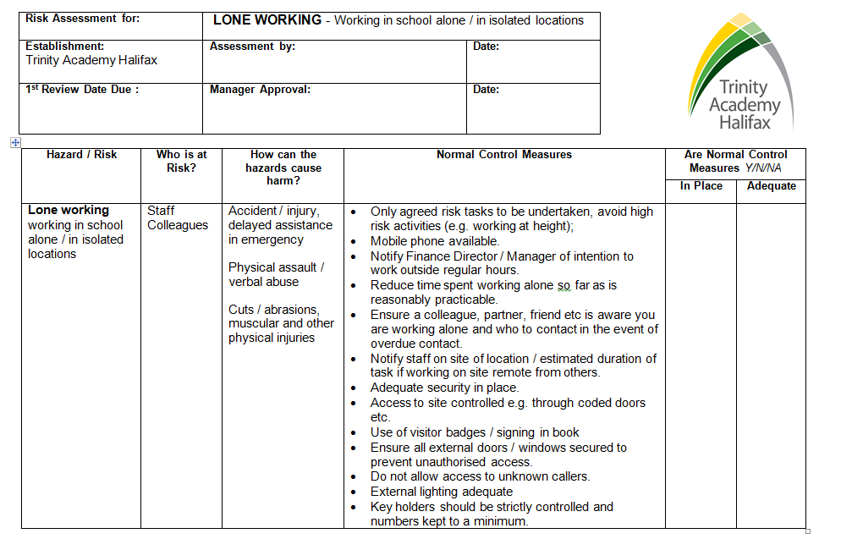
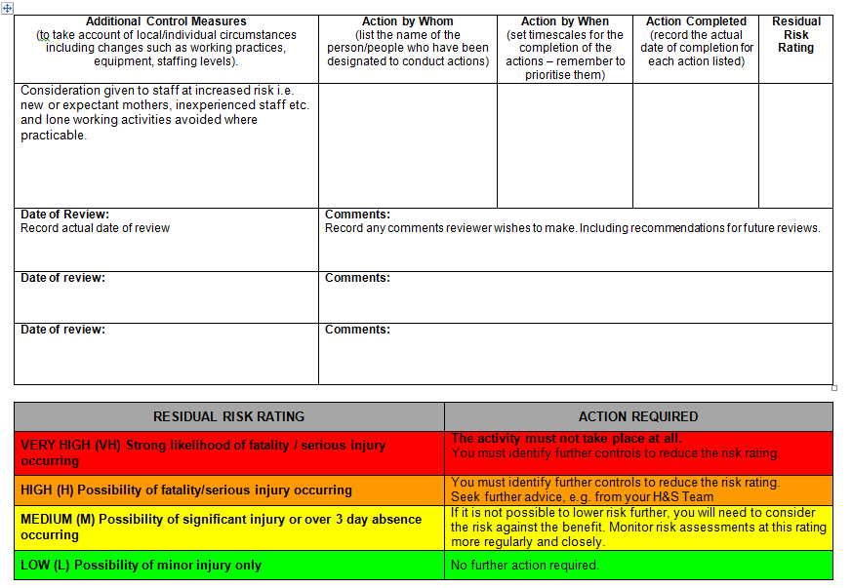

Appendix 3 – Responsible Person by Academy

Trinity Academy Halifax:

Name | Role
Nick Robinson | Principal
Peter Dakin | Premises Manager (the Health and Safety Co-ordinator)
Gillian Bridge | First Aid Co-ordinator
Gillian Bridge | Medical Welfare Officer (MWO)
Peter Dakin | Educational Visit Co-ordinator (EVC)

Trinity Academy Sowerby Bridge:

Name | Role
Charlie Johnson | Principal
John Lister | Premises Manager (the Health and Safety Co-ordinator)
Jessica Taylor | First Aid Co-ordinator
Jessica Taylor | Medical Welfare Officer (MWO)
John Lister | Educational Visit Co-ordinator (EVC)

Cathedral Academy:

Name | Role
Rob Marsh | Principal
Gordon Easingwood/Heather Eyre | Premises Manager (the Health and Safety Co-ordinator)
Karen Scholey | First Aid Co-ordinator
Karen Scholey | Medical Welfare Officer (MWO)
Maria Stead | Educational Visit Co-ordinator (EVC)

Trinity Sixth-Form Academy:

Name | Role
Michael Fitzsimmons | Principal
Robert Boocock | Premises Manager (the Health and Safety Co-ordinator)
Rachel Henry | First Aid Co-ordinator
Rachel Henry | Medical Welfare Officer (MWO)
Robert Boocock/Tanya Surtees | Educational Visit Co-ordinator (EVC)

Akroydon Primary Academy:

Name | Role
Annie McNally | Principal
Chris Chandler | Premises Manager (the Health and Safety Co-ordinator)
Sue Falmer | First Aid Co-ordinator
Sue Falmer | Medical Welfare Officer (MWO)
Lydia Tongue | Educational Visit Co-ordinator (EVC)

St Chad Primary Academy:

Name | Role
Samantha Hirst | Principal
Kevin Pearson | Premises Manager (the Health and Safety Co-ordinator)
Sharon Horner | First Aid Co-ordinator
Sharon Horner | Medical Welfare Officer (MWO)
Tom Smaldon | Educational Visit Co-ordinator (EVC)

Trinity Academy St Peter:

Name | Role
Lynsey Mitchell | Principal
Mary Wray | Premises Manager (the Health and Safety Co-ordinator)
Melanie Crawshaw | First Aid Co-ordinator
Melanie Crashaw | Medical Welfare Officer (MWO)
Samantha Helsop | Educational Visit Co-ordinator (EVC)

The Maltings:

Name | Role
Peter Knight | Chief Operating Officer
 | Premises Manager (the Health and Safety Co-ordinator)
 | First Aid Co-ordinator
 | Medical Welfare Officer (MWO)
 | Educational Visit Co-ordinator (EVC)

