Dear Parent/Carer,

While your child is unable to attend school due to self isolating, we want to ensure they do not fall behind and are still able to access all of the lessons they would be having in school. Your child has already been taught how to access home learning via Microsoft Teams. To access Teams your child will need to:

1. Visit [www.office.com](http://www.office.com) or download the free ‘Microsoft Teams’ app if using a mobile device.
2. Sign in using their school email. This will be their usual computer login with the address ‘@sowerby.trinitymat.org’. The password is their usual log in.
3. Select ‘Teams’ from the menu running down the left hand side of the page.
4. Select the ‘Teams’ tab once the window loads.

Your child will have a class team for each subject they study, and work can be found in the ‘files’ tab from the menu running across the top of the team as shown below:

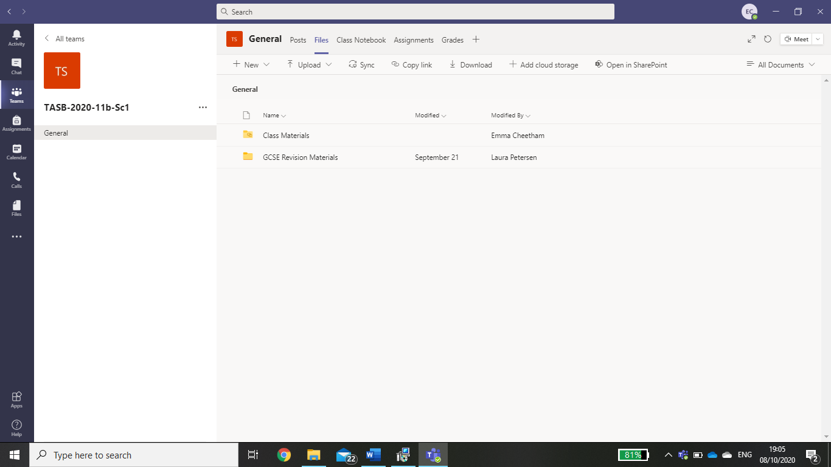

Work will be available in the ‘Class Materials’ folder for Term 2 Week 1. This will ensure students can follow their usual timetable and will have access to the lesson powerpoint and resources they would have been using in school. Once complete if students can take a picture of any work completed on paper, or attach any electronic documents, in an email to their class teacher so that they can provide any necessary feedback.

Please do get in touch if you have questions on any of the above or would like to discuss any other matter.

Thank you for your continued support.

Kind regards,



Charlie Johnson

Principal