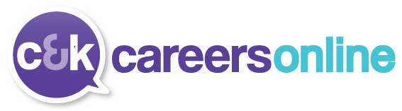
www.ckcareersonline.org.uk - click to see careers and job trends information, vacancies, advice for students, parents/carers, teachers/advisers, adults and employers. Includes leaflets, booklets, videos, case studies and more.

Careers at Trinity Academy Sowerby Bridge
Welcome

C&K Careers works with Trinity Academy Sowerby Bridge to provide students, from Year 7 to Year 11, with independent careers Information, Advice and Guidance. Helping you, when you need it, to make important decisions and choices about your future plans. Our advisers have qualifications in careers guidance and experience working with students from a variety of backgrounds.

Your Trinity Careers Team:
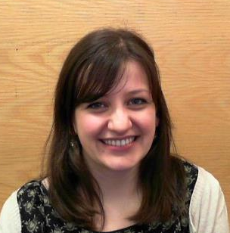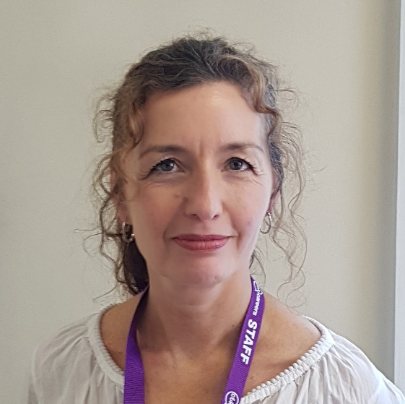

Caroline Green Suzanne Dutton

To contact the careers team:
Email: Caroline – caroline.green@ckcareers.org.uk 01484 213369
Suzanne – suzanne.dutton@ckcareers.org.uk 01484 213230
Visit: the careers room in B2/33
Ring: C&K Careers on 01484 242000 and ask for you adviser by name

Your careers adviser supports you by:
- Providing information, advice and guidance on careers, college, sixth form, apprenticeships and university
- Offering one-to-one appointments, group sessions and the opportunity to drop-in during break and lunch time to ask questions, pick up information and discuss your plans
- Help with College, Sixth Form, Apprenticeship applications, writing CVs and looking for volunteering opportunities.
- Attending parents evenings and a number of other school events to meet with you, your parents and carers

