10 July 2020

Dear Parent / Carer

Please find enclosed a copy of the Academy uniform policy, please pay special attention to the footwear section. From September our full uniform policy must be adhered to at all times. Staff will check that students are wearing the correct uniform every morning, any student not wearing the correct uniform will result in parents/carers receiving a phone call and your child will need to borrow uniform from the uniform store. Detentions may also be given if students continue to wear the incorrect uniform.

If you have any queries regarding this then please do not hesitate to contact the Academy on the number below.

Yours sincerely

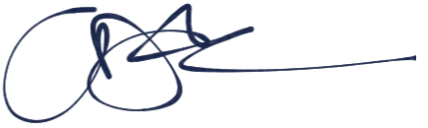

Mr Johnson

Principal